Name : Priyanka Ramesh Talokar

College : Government College of engineering ,Nagpur

Year :2nd year

Branch :CSE

GitHub account link : https://github.com/priyanka2111-talokar

**MAJOR PROJECT-1**

**1.CHOOSE ANY DATASET OF YOUR CHOICE AND APPLY A SUITABLE CLASSIFER/REGRESSOR**

**LINEAR REGRESSOR :-**

**Colab notebook : https://colab.research.google.com/drive/1_D7h6_cI6K4IY6qbwEL-ORnyFYZ690cA?usp=sharing**

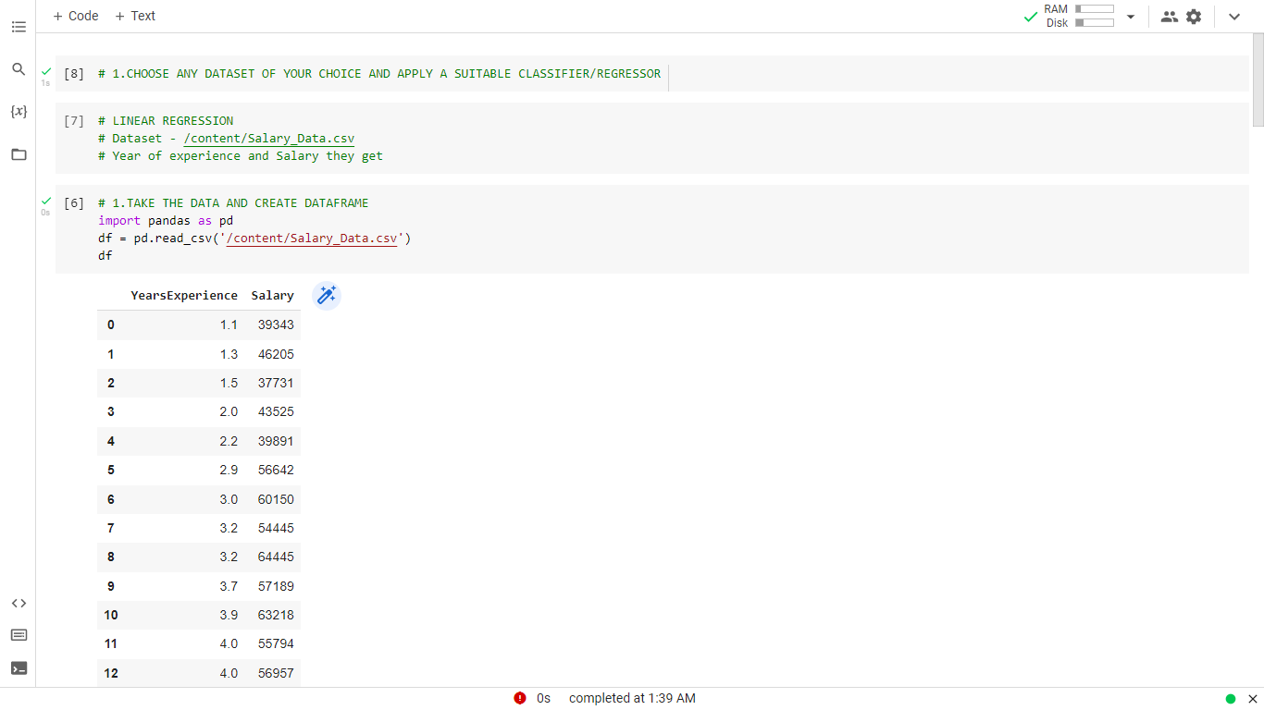

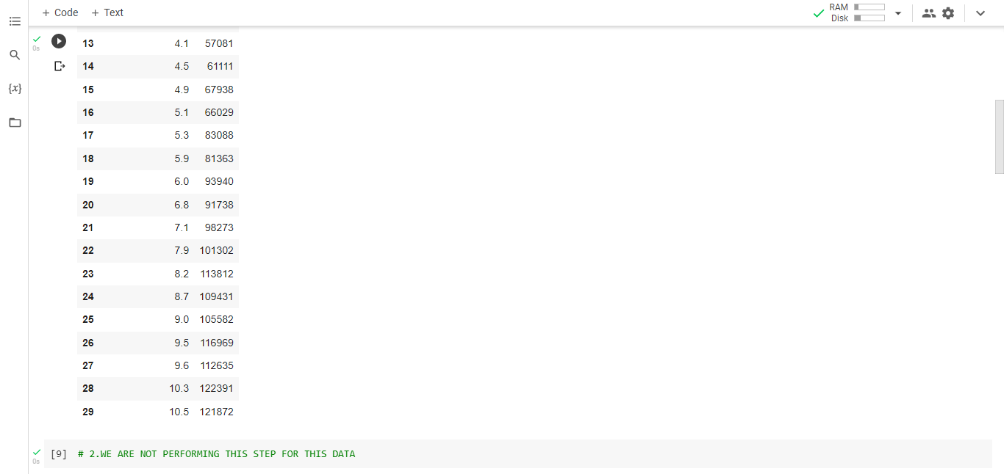

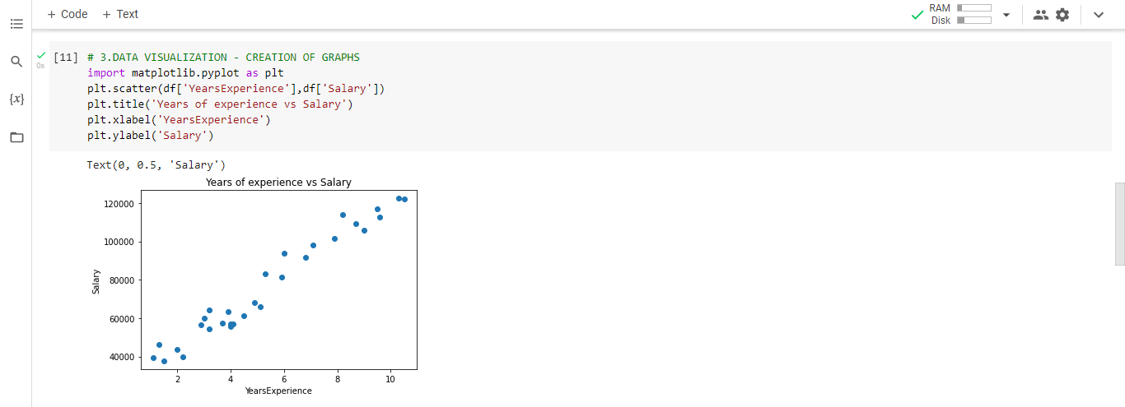

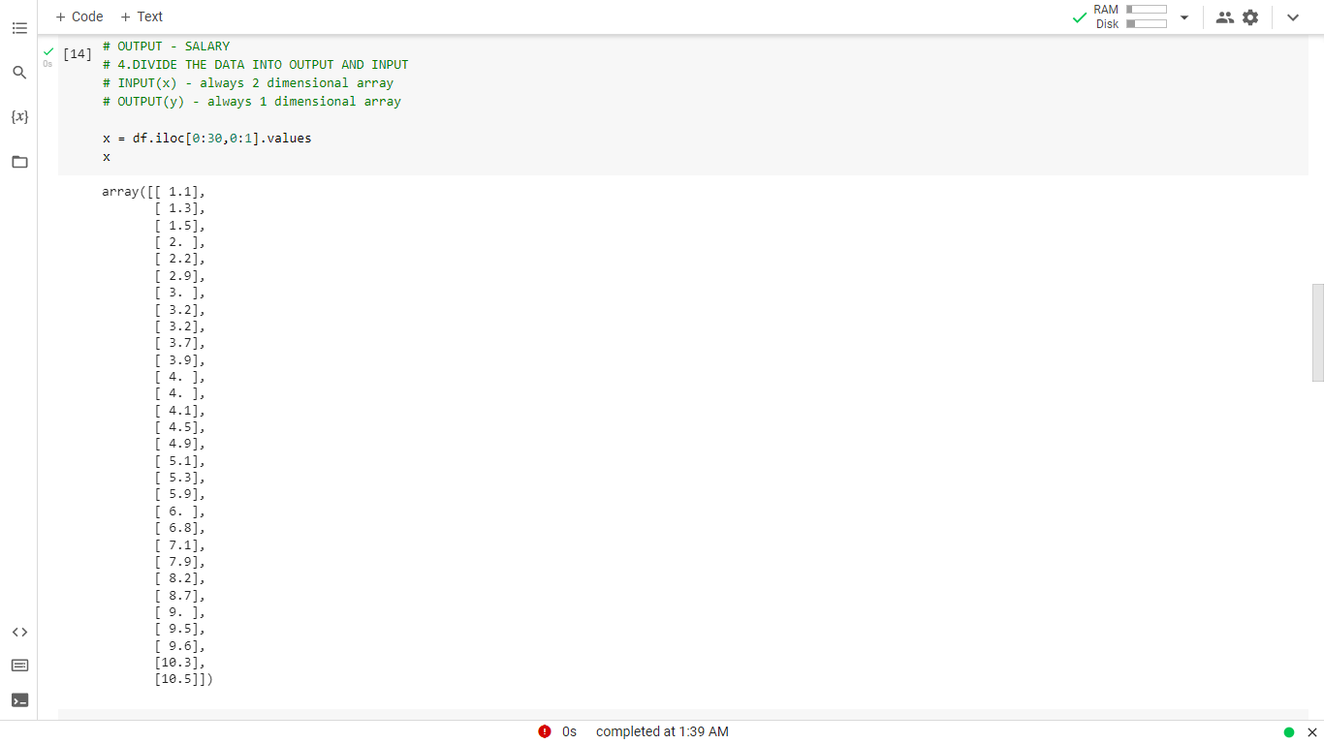

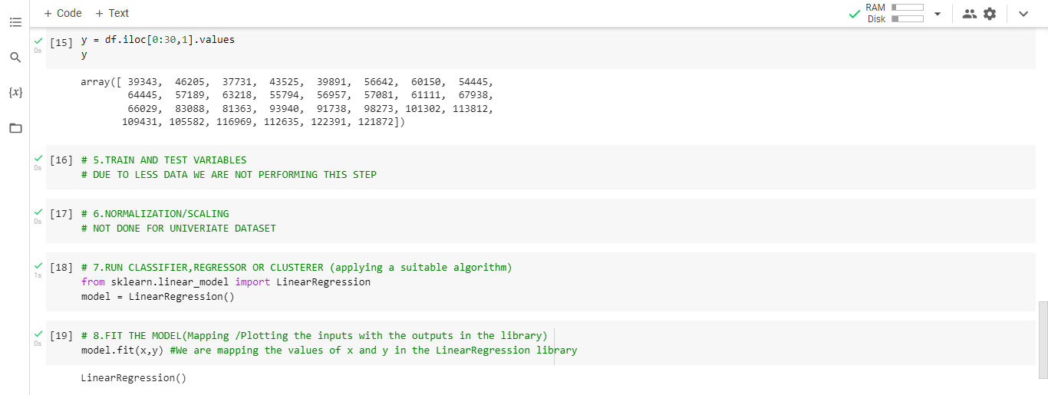

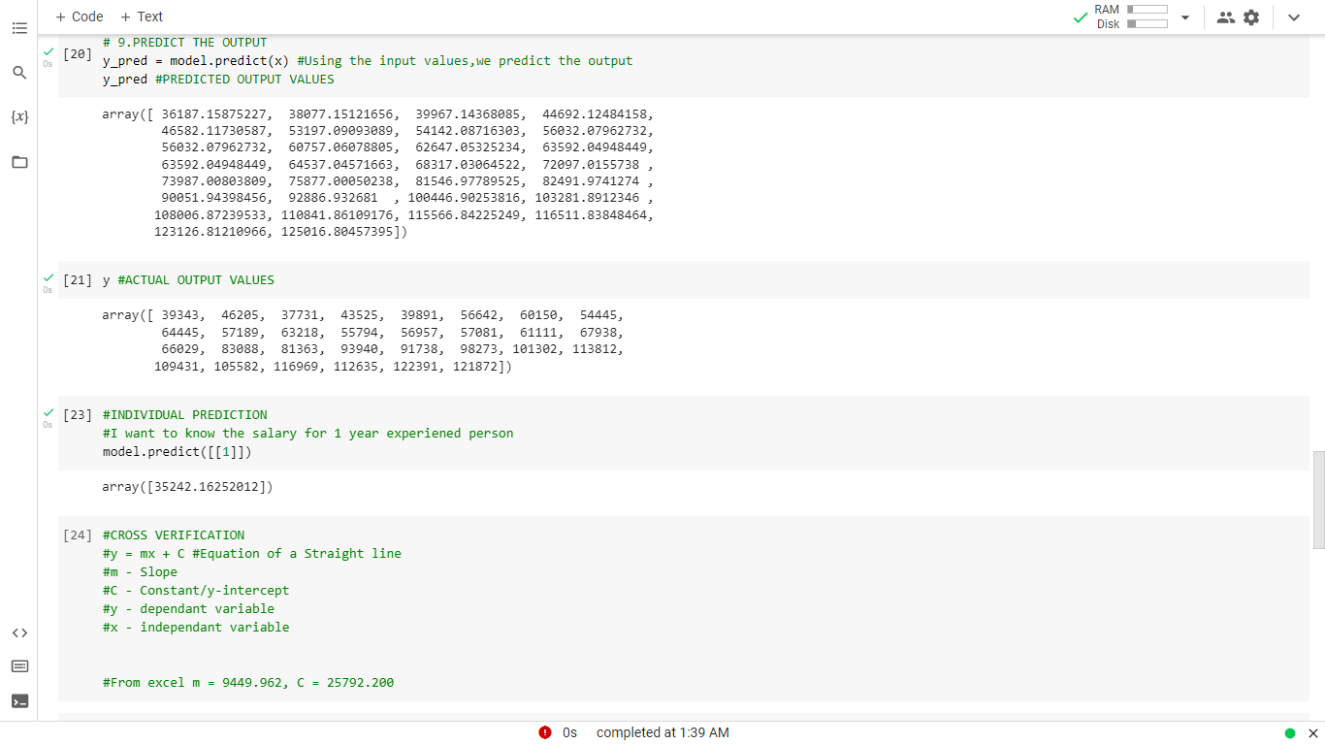

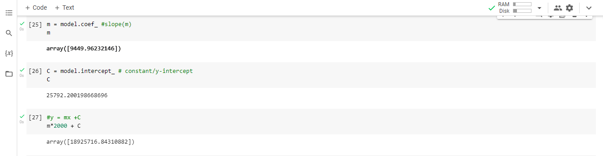

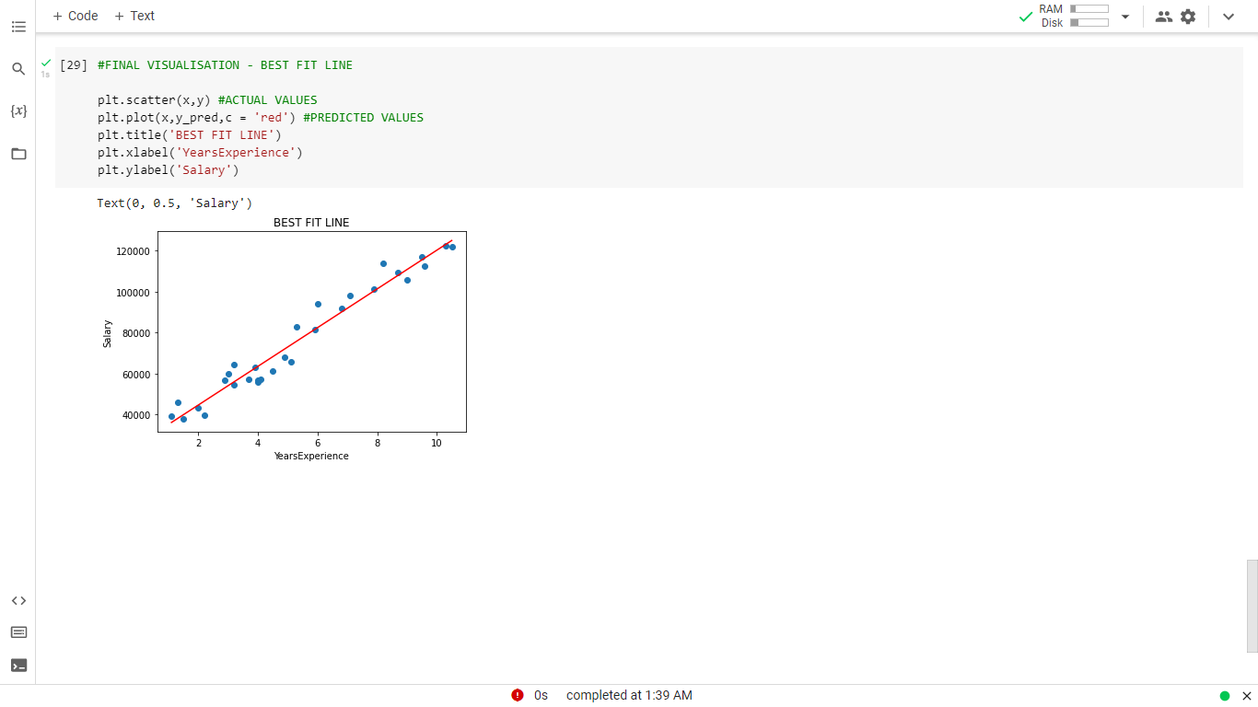

**MAJOR PROJECT 2**

**2.CHOOSE ANY DATASET OF YOUR CHOICE AND PERFORM EDA FOR ATLEAST 15 DIFFERENT FACTS/CONCLUSIONS**

**Colab notebook : https://colab.research.google.com/drive/1XGxwtHvGq-3QNPkdo0YZ07C7Yqfa3keR?usp=sharing**

